**Release 1 and Sprint Plan 1,2**

**Group 15, Fridays 9am – 11am, GP Q-224**

|  |  |
| --- | --- |
| **Student Number** | **Team Member Name** |
| 08621497 | **Dall’Osto** Aden |
| 09440488 | **Deakin** Tom |
| 09312692 | **Fan** Joey |
| 09455477 | **Henry** Samuel |
| 09154507 | **Hunter** Megan |
| 08886229 | **McLeod** Maxwell |
| 09162259 | **Stanger** Jesse |

Tutor: Mr. Muthu Ramanathan

Release 1

Date: 23/09/2016

**Table of Contents**

Release Plan 1

Release 1 1

Release 2 2

Release 3 3

Release 4 4

Delivery Schedule 5

Sprint Plan 6

Sprint 1 6

Sprint 2 9

Burn Down charts 12

# Release Plan

## Release 1

Delivery date: **Week 9 – 23rd September 2016** Total Story Points: **56**

Release 1 will see the creation of the base functionalities of the website. It will deliver a quantifiable product that can be delivered to the client with minimal functionality. This includes the base components of the site; event management, user management, UI and processing. This release is intended as a minimal viable product for the customer and uses agile methodologies to allow for feedback and any possible expected changes the client may request.

**Feature 1: User Management and UI**

This feature aims to provide a full user login and management system so users can be tracked on each page of the site, providing users with details and account customisation. It shows the development of the core user interface of the site which is established into this feature as a base for future development of the website. This provides the customer with accurate and up to date details on their clients whilst being able to uphold their image and branding through the use of the UI. Thus providing business value through customer information, branding and website functionality.

|  |  |  |
| --- | --- | --- |
| Story ID | Story Title | Story Points |
| 3 | Event Finder | 2 |
| 11 | Update Details | 2 |
| 14 | Terms of Service | 1 |
| 22 | Personal Information Security | 8 |
| 23 | Simple Website Navigation | 2 |
| 24 | User Verification | 2 |
| 25 | Cross Platform Support | 4 |
|  | Story Point Sub-Total: | 21 |

**Feature 2: Event Management**

As the core functionality of the website the event management feature controls all user created events, information distribution and social networking interactions. It provides the clients users with a portal and functional tool and therefore provides value to the client as a functioning product. Using this tool, the client will be able to carry out their business operations using this product as their service.

|  |  |  |
| --- | --- | --- |
| Story ID | Story Title | Story Points |
| 1 | People Status | 1 |
| 2 | Preview Ad | 4 |
| 6 | Unique URL | 1 |
| 7 | Local Event Finder | 2 |
| 9 | Cancel Events | 1 |
| 12 | Social Media | 2 |
| 29 | User Following | 8 |
| 31 | Creating Events | 16 |
|  | Story Point Sub-Total: | 35 |

## Release 2

Delivery date: **Week 13 – 21st October 2016** Total Story Points: **53**

This release aims to provide the client with additional features on top of the core functionality of the website as per their requirements. It will focus on adding processing and payments systems to the website enriching the end-users experience and adding value to the client’s service. The completion of this release will see the following two features completed as goals.

**Feature 1: Processing**

This feature of the website runs many important systematic processes used in many of the functional running elements of the website such as communications and event management. It is intended to provide the end-user with features and at its core runs unnoticed to create a fully functioning website. It provides value to the client by enriching their service through a strong base foundation to ensure seamless functionality.

|  |  |  |
| --- | --- | --- |
| Story ID | Story Title | Story Points |
| 10 | Contact Organiser | 4 |
| 13 | Charity Organisation | 4 |
| 16 | Event Confirmation | 1 |
| 4 | Change Details | 4 |
| 19 | Special Event | 8 |
| 28 | Donation Documentation | 4 |
|  | Story Point Sub-Total: | 25 |

**Feature 2: Payments**

Payments, donations and payment summaries are managed through the addition of this feature. This provides value to the client’s business as the direct means for payment from their service. Accurate payment management and reporting is also important to the organisations legal requirements. It is addressed in this feature with many automated systems. Providing the firm value through time saving and prevention of unwanted financial uncertainties.

|  |  |  |
| --- | --- | --- |
| Story ID | Story Title | Story Points |
| 8 | Money Maker | 2 |
| 17 | Multiple Donations | 2 |
| 20 | Payment Management | 4 |
| 21 | Donation Payment | 4 |
| 26 | Payment Summary | 8 |
| 18 | Committee | 8 |
|  | Story Point Sub-Total: | 28 |

## Release 3

Delivery date: **Week 17** (Hypothetical) Total Story Points: **42**

This release will provide the user with a more complete and refined product. With the end-user in mind through the design of this release many service additions, ease of access and utility based features will be added. This will provide value to the client by diversifying their brand and strengthening their product. Possibly enticing more customers to use the service while improving the experience for current clients.

**Feature 1 – Notification**This feature is about improving the end product. This feature will allow for smooth functionality of the website allowing all information to be found. This will add business value by ensuring users can easily find and manage events.

|  |  |  |
| --- | --- | --- |
| Story ID | Story Title | Story Points |
| 15 | User Updates | 2 |
| 5 | Communication between organisers | 8 |
| 32 | Notification Changes | 4 |
| 33 | Alert Creation | 8 |
| 35 | Notification of Payment | 4 |
|  | Story Point Sub-Total: | 20 |

**Feature 2 – Mobile Phone Integration**

This feature provides a mobile phone web application of the website. Used for all clients and provided as an additional service feature of the product.

|  |  |  |
| --- | --- | --- |
| Story ID | Story Title | Story Points |
| 36 | Phone Location | 4 |
| 37 | Create QR Code | 8 |
| 34 | Push to Phone Calendar | 8 |
| 38 | Phone Log-in | 2 |
| 39 | Event Share | 2 |
|  | Story Point Sub-Total: | 22 |

## Release 4

Delivery date: **Week 21** (Hypothetical) Total Story Points: **59**

The goal of this release is to allow for event merchandising and advanced user personalisation. The goals of this release are to provide value to the end-consumer and client. The purpose of the merchandising allows more money to be generated, allowing more events to be held. The advanced user personalisation will deliver utility and value to the end-user.

**Feature 1 – Merchandising**

This feature will allow more money to be generated to events. Merchandising will allow the event and subsequent information to be spread quicker through the use of branding. This in turn will get more people to the event and increase amounts donated to the business.

|  |  |  |
| --- | --- | --- |
| Story ID | Story Title | Story Points |
| 40 | Merchandise | 2 |
| 41 | Merchandise Inventory | 4 |
| 44 | Merchandise Contact | 1 |
| 45 | User Purchasing Merchandise | 8 |
| 46 | Merchandise Levels | 8 |
|  | Story Point Sub-Total: | 23 |

**Feature 2 – Advanced User Personalisation**

This feature will allow users to interact with each other and the system in a coherent environment. This in turn will allow users to network and find other people and will lead to more donations for events. This will add business value as it will generate more advertising and interest in events.

|  |  |  |
| --- | --- | --- |
| Story ID | Story Title | Story Points |
| 42 | Advanced Interaction | 2 |
| 43 | User Customize | 8 |
| 47 | Amount Donated | 2 |
| 48 | Friend Finder | 8 |
| 49 | User Time Frame | 16 |
|  | Story Point Sub-Total: | 36 |

# Delivery Schedule

|  |  |  |  |  |  |  |  |  |
| --- | --- | --- | --- | --- | --- | --- | --- | --- |
| Week 6 | Week 7 | Week 8 | Week 9 | Week 10 | Week 11 | | Week 12 | Week 13 |
| Sprint 1 | | Sprint 2 | | Sprint 3 | | Sprint 4 | | Sprint 5 |
| Release 1 | | | | Release 2 | | | | |

|  |  |  |  |  |  |  |  |
| --- | --- | --- | --- | --- | --- | --- | --- |
| Week 14 | Week 15 | Week 16 | Week 17 | Week 18 | Week 19 | Week 20 | Week 21 |
| Sprint 6 | | Sprint 7 | | Sprint 8 | | Sprint 9 | |
| Release 3 | | | | Release 4 | | | |

Estimated Velocity: 21

# Sprint Plan

## Sprint 1

Total Story Points: 21 Total Hours:**31**

Current Velocity: *undefended*

**Story ID: 22 – Personal Information Security**

|  |  |  |  |
| --- | --- | --- | --- |
| Task ID | Task Description | Estimate | Taken |
| 1 | Create Login and Signup Page | 2 | 1 |
| 2 | Create User Database | 2 | 1.5 |
| 3 | Program User Authentication | 4 | 2 |
| 4 | Create User tracking through cookies | 1 | 1 |
| 5 | Develop and implement System to send users change password verification email | 1 | 1 |
|  | Story Points: 8 Total Hours: | 10 | 7.5 |

When creating a user log in page and signup page this was quite easy to do and took less than the 2 hours dedicated to the task. Creating the user database also took less time than the allocated time of 2 hours this was due to the knowledge of the group to create this page. Creating the system for users to change passwords hasn’t yet been implemented but was discussed with the client group and will be done in sprint 3.

**Story ID: 11 – Update Details**

|  |  |  |  |
| --- | --- | --- | --- |
| Task ID | Task Description | Estimate | Taken |
| 6 | Create user update page | 1 | 1 |
| 7 | Program system to implement form and update database | 1 | 1 |
| 8 | Program system to allow users to fetch their current information which is input into the update user page as prefilled form information | 1 | 1 |
|  | Story Points: 2 Total Hours: | 3 | 3 |

Creating a user update page was done with some errors. These errors are small and do not affect the functionality of the website. When updating the user’s credentials if some of the credentials stay the same the database will come back with an error however will update the fields that have changed. The systems fetching ability hasn’t been implemented into the website however was approved by the client to be put into sprint 3.

**Story ID: 24 – User Verification**

|  |  |  |  |
| --- | --- | --- | --- |
| Task ID | Task Description | Estimate | Taken |
| 9 | Program checks to verify the user to authenticate they are the correct person upon click to make a payment | 2 | 0 |
| 10 | Program base functionality to send verified user information to possible future payment systems such as PayPal. | 1 | 0 |
|  | Story Points: 2 Total Hours: | 3 | 0 |

The program to check if the user is the user upon payment hasn’t been implemented. It was discussed with the client and they have decided that they do not need this as if information is stolen the last place they would do with the money would be to donate it to an event. PayPal integration has not yet been implemented however will be added to sprint 4.

**Story ID: 3 – Event Finder**

|  |  |  |  |
| --- | --- | --- | --- |
| Task ID | Task Description | Estimate | Taken |
| 11 | Design a user interface that is clean and helps the user guide the user to possible future events. | 1 | 1 |
| 12 | Create a list that is populated with all active events. This will reside on the index page after login. | 1 | 1 |
| 14 | Create sorting and search function for list. | 1 | 1 |
|  | Story Points: 2 Total Hours: | 3 | 3 |

Making the event finder easy to find and easy to use was a major requirement for the client. This is because the client’s charities will be holding events details on their webpage. It needs to be easy to use so more people will use it and be able to understand how to navigate. Creating a search and sorting function was done but took longer than the allocated time because lack of knowledge in the team.

**Story ID: 14 – Terms of Service**

|  |  |  |  |
| --- | --- | --- | --- |
| Task ID | Task Description | Estimate | Taken |
| 15 | Create a dedicated page for site-wide terms of service page | 1 | 0.5 |
| 16 | Create applicable links on site for the terms of service page and populate with Lorem Ipsum | 1 | 1.5 |
|  | Story Points: 1 Total Hours: | 2 | 2 |

Terms and conditions where completed within the time. More time was concerned on what Lorem Ipsum to use than the implementation of the hyperlink.

**Story ID: 23 – Simple Website Navigation**

|  |  |  |  |
| --- | --- | --- | --- |
| Task ID | Task Description | Estimate | Taken |
| 17 | Create system for location based services on the website | 2 | 1 |
| 18 | Add search feature to event finder to allow for sorting by local area | 1 | 1.5 |
| 19 | Verify location services using Google Maps API | 2 | 1 |
|  | Story Points: 4 Total Hours: | 5 | 3.5 |

Creating the website to allow for location services took less time than the group thought. This was due to the groups knowledge in geo location coding. This addition has added great functionality to the website.

**Story ID: 25 – Cross Platform Support**

|  |  |  |  |
| --- | --- | --- | --- |
| Task ID | Task Description | Estimate | Taken |
| 20 | Program device screen resolution recognition script for use on each page of the website | 2 | 2 |
| 21 | Create Custom CSS pages for a standard mobile and desktop based application as requested in the user story feedback. | 1 | 1 |
| 22 | Program responsive website elements to conform to task 20 and 21 specifications. | 2 | 2 |
|  | Story Points: 4 Total Hours: | 5 | 5 |

Implementing cross platform support took the time quoted above. No problems arose with multiple testing been able to be done in the time allocated.

## Sprint 2

Total Story Points: 35 Total Hours: 57

Current Velocity: *undefined*

**Story ID: 1 – People Status**

|  |  |  |  |
| --- | --- | --- | --- |
| Task ID | Task Description | Estimate | Taken |
| 23 | Create database statements to count user attendance at events | 2 | 2 |
| 24 | Create tally on event page to indicate number of people attending an event | 1 | 1 |
|  | Story Points: 1 Total Hours: | 3 | 3 |

Creating the SQL statements for this is easy and should only take at maximum 2 hours to complete this is due to everyone’s ability in MYSQL. However due to the website not yet accommodating the underlying features of a user attending an event the query cannot be done just yet and will need to be pushed to sprint 3.

**Story ID: 2 – Preview Ad**

|  |  |  |  |
| --- | --- | --- | --- |
| Task ID | Task Description | Estimate | Taken |
| 25 | Allocate temporary storage in database for active event creation. | 2 | 1 |
| 26 | Create preview page to show elements of the user created event page. | 4 | 3.5 |
| 27 | Create overlay on preview page for real time editing of the preview page or a button to take the user back to the editing page. | 4 | 4 |
|  | Story Points: 4 Total Hours: | 10 | 8.5 |

This was done but with some difficulty. The creating a preview page was done with more time taken than first thought. The event preview page was done however when pushing to the database errors were thrown back as the data was saved locally but not to the database hence not saving any work that had been done by the user.

**Story ID: 6 – Unique URL**

|  |  |  |  |
| --- | --- | --- | --- |
| Task ID | Task Description | Estimate | Taken |
| 28 | Program script to create a unique URL for each event page | 1 | 1 |
| 29 | Display button on event page to copy unique URL | 1 | 1 |
| 30 | Display button on event management page to copy unique URL | 1 | 1 |
|  | Story Points: 1 Total Hours: | 3 | 3 |

Creating a unique URL was easy to create and manage with an extension in the database automatically adding a number to each event and then storing it in a unique URL each time. The button was simple to add in with the clipboard copying easy to create due to the experience of everyone’s coding ability.

**Story ID: 9 – Cancel Events**

|  |  |  |  |
| --- | --- | --- | --- |
| Task ID | Task Description | Estimate | Taken |
| 31 | Create button on event page for users to cancel interest in the event | 1 | 2 |
| 32 | Write database query to update event details | 1 | 1 |
| 33 | Remove user from active event goers list | 1 | 1 |
|  | Story Points: 1 Total Hours: | 3 | 4 |

Cancel events function allowed events to be cancelled if the organiser doesn’t raise enough money or doesn’t get the required turnout that the organisation wanted. This at the moment allows anyone to cancel an event and delete all entries in the database. With release 2 this will be fixed and just allow the event creators to manage events.

**Story ID: 12 – Social Media**

|  |  |  |  |
| --- | --- | --- | --- |
| Task ID | Task Description | Estimate | Taken |
| 34 | Link Facebook page to website using authorised links | 1 | 1 |
| 35 | Create button on event page to connect users Facebook to events | 2 | 1 |
| 36 | Enable user comments on event page using Facebook API | 2 | 2 |
|  | Story Points: 2 Total Hours: | 5 | 4 |

The social media plug in was completed and didn’t take too much time. This function allows the user to share the event they are going to or organising to Facebook. Using the Facebook API, it was a simple integration.

**Story ID: 29 – User Following**

|  |  |  |  |
| --- | --- | --- | --- |
| Task ID | Task Description | Estimate | Taken |
| 37 | Create a follow button on event pages that links the active user’s login to the user associated with the applicable event | 4 | 2 |
| 38 | Create system to send email by integrating Gmail with firebase. | 4 | 4 |
| 39 | Create button for organiser to send an email to all followers | 1 | 2 |
| 40 | Create and Unfollow button for users that have followed an organiser on their personal settings page. | 2 | 2 |
|  | Story Points: 8 Total Hours: | 11 | 10 |

Creating this functionality of the website took more time than first planned and still isn’t fully complete. The integration of email is a tricky and difficult addition because the server has to process a lot of data for each user. The following a page was done without too much of a problem however still needs more tweaking in release 2.

**Story ID: 31 – Creating Events**

|  |  |  |  |
| --- | --- | --- | --- |
| Task ID | Task Description | Estimate | Taken |
| 41 | Develop database to store event information | 2 | 2 |
| 42 | Create generic statements to retrieve information from the database | 2 | 2 |
| 43 | Develop webpage form that organisers can use to create events | 4 | 4 |
| 44 | Provide link on verified organisers page to access the event creation system as described in task 43 | 4 | 4 |
| 45 | Create dedicated backend for events webpage | 2 | 4 |
| 46 | Develop scripts to log event details and actions | 2 | 2 |
| 47 | Develop system for live updates that can be provided to the organiser | 4 | 4 |
|  | Story Points: 16 Total Hours: | 22 | 24 |

Developing the webpage to allow for organisations to create events had problems in the infancy. This was due to the group not deciding how to go about storing the data about an event and what to capture and not capture. Developing a system for a live update was decided by the group that this could be done last to allow for more important parts of the website to be done.

# Burn Down charts

**Burn Down Chart 1**

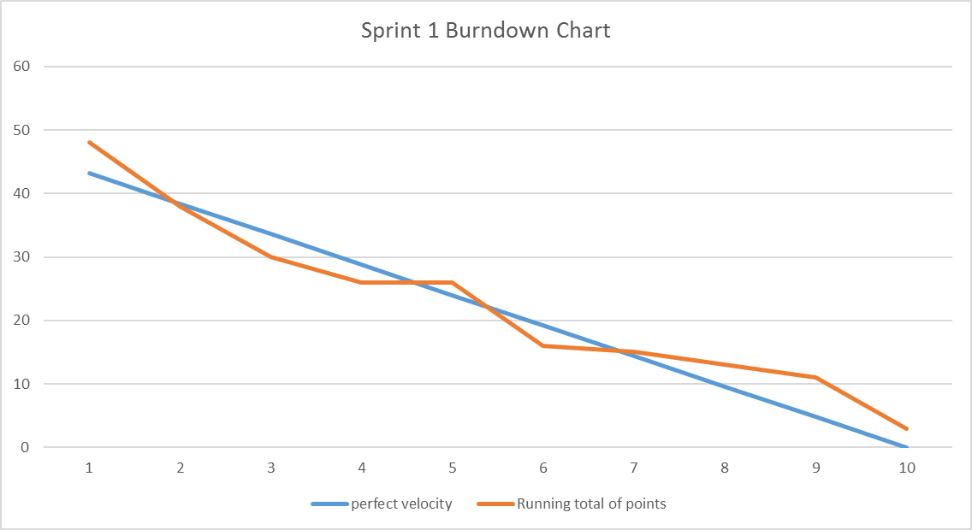

Above is the graph of progression in sprint 1. This graph shows the relationship between story points and days taken to do the required task. As shown above the sprint wasn’t fully completed. The blue line indicates how the task should be done if completed on time within the time frame of 10 days. The orange line shows what actually happened. As shown above the orange line shows that the group was able to complete most tasks within the time frame however towards the end it shows that the group was not able to accomplish the tasks in sprint 1. This is due to the harder tasks being pushed back further to ensure all other tasks were done properly.

**Burn Down Chart 2**

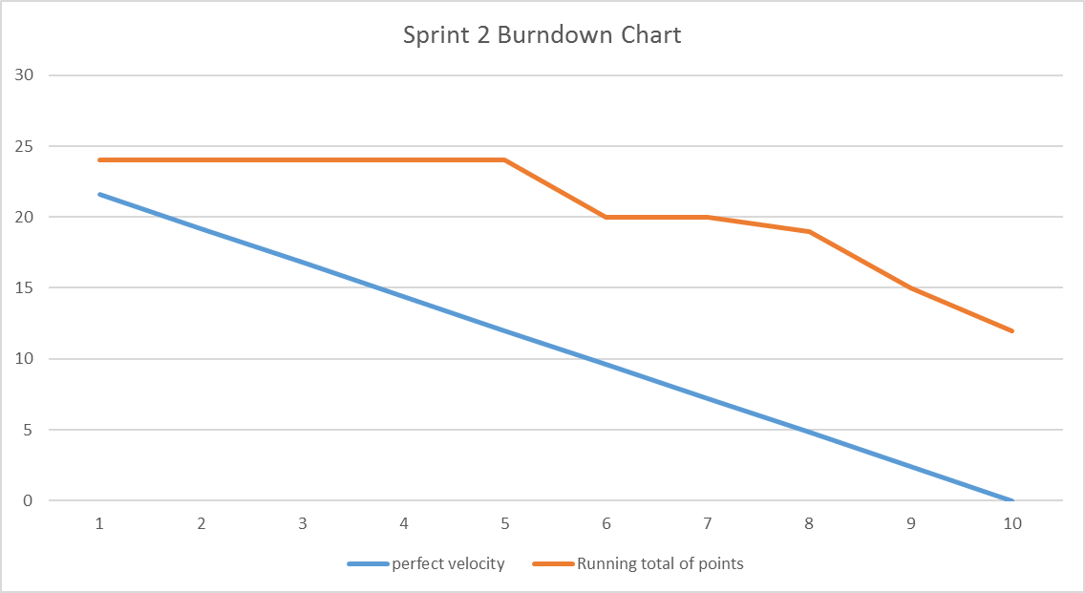

The above graph shows the relationship between story points and the perfect time to complete all story points before deadline. The blue line represents the perfect time to take for the sprint to be completed and the orange line is the time it actually took to complete. As shown above the orange line is nowhere near being done. This was due to the work being pushed back from sprint 1 onto sprint 2 where all hard tasks in sprint 1 are still not complete however were attempted which in turn hindered sprint 2’s features. This has been noted and serious work needs to be done for sprint 3 and sprint 4.